Lecture 21, November 2, 2010 (Key Points)

We concluded Lecture 20 with a space-time representation of conditional mean discharge,
(21.1)
It involves two conditional mean functions, representing mean excess rainfall given duration, and representing mean basin response function given its duration. Eq. (21.1) is a stochastic generalization of GIUH in a convolution equation. Our task is to develop a general expression for stream discharge in GCEW that requires three characteristics of the basin: (1) the general shape of the mean excess rainfall time series in the basin during a rainfall-runoff event, (2) the general shape of the basin's mean response function, and (3) the way that the response function is parameterized with respect to drainage area. As explained below, these three characteristics are evaluated from conditional-mean time series of estimated excess rainfall and conditional-mean functions for simulated basin response.

21.1 Estimating mean excess rainfall given duration

The mean shape of excess rainfall time series in GCEW was assessed using estimated time series for each of 148 rainfall-runoff (RF-RO) events in the basin (Furey and Gupta 2005). A time series was estimated for an event by applying an infiltration threshold “loss rate independent of rainfall intensity” to rainfall intensity time series (Brutsaert, 2005, p. 345). It is also called the ‘Phi-Index Method’ in the engineering hydrology literature. It is a water balance method applied to spatially averaged rainfall intensity and streamflow hydrograph at the outlet of a basin.
The approach and results of this estimation are discussed in Furey and Gupta (2005) and are not reviewed here. Figure 21.1 illustrates the problem that arises when evaluating a mean time series without conditioning; it also arises when evaluating a mean function for basin response.
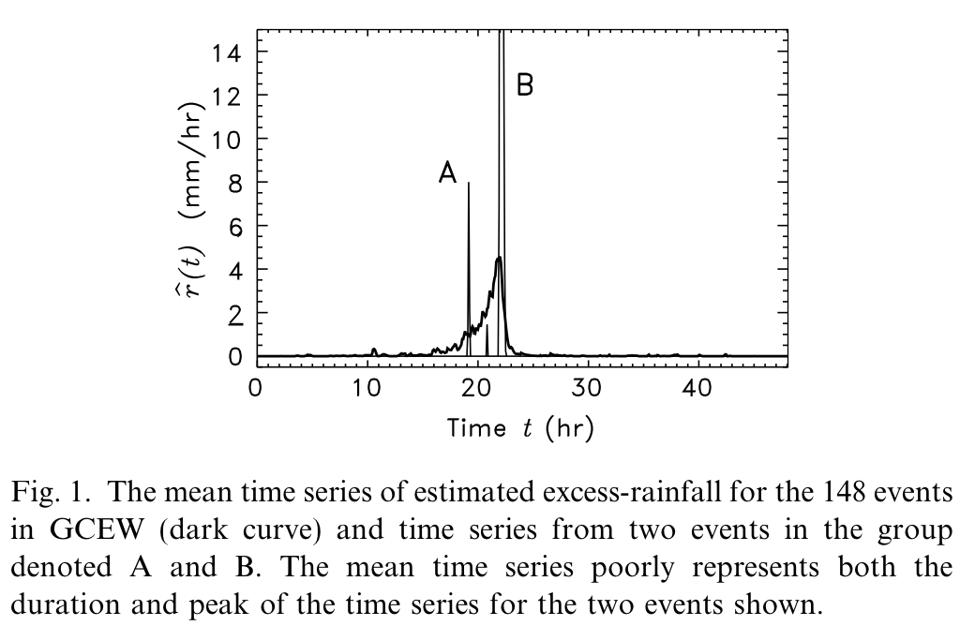
Figure 21.1 Evaluating a mean time series without conditioning

The excess rainfall duration for each time series uses a surrogate measure defined as , where is the depth of estimated excess rainfall (mm) and is the peak of estimated excess rainfall (mm/hr). A mean excess rainfall time series was evaluated by conditioning the events on a narrow range of values.
Excess rainfall time series, conditioned on a range of values, must be centered on a common feature to produce a mean time series from them. One approach is to center the time series on their peaks, so that each excess rainfall peak occurs at the same moment in time. A second approach is to center the excess rainfall time series on the streamflow peaks, recorded at the outlet of GCEW, to which they correspond. Regardless of which centering approach is used, we found that a Gaussian function is a reasonable first-order approximation for the general shape of the mean time series of excess rainfall in GCEW conditioned on duration. Figure 21.2 shows the results of the conditional analysis for the second centering approach discussed above.

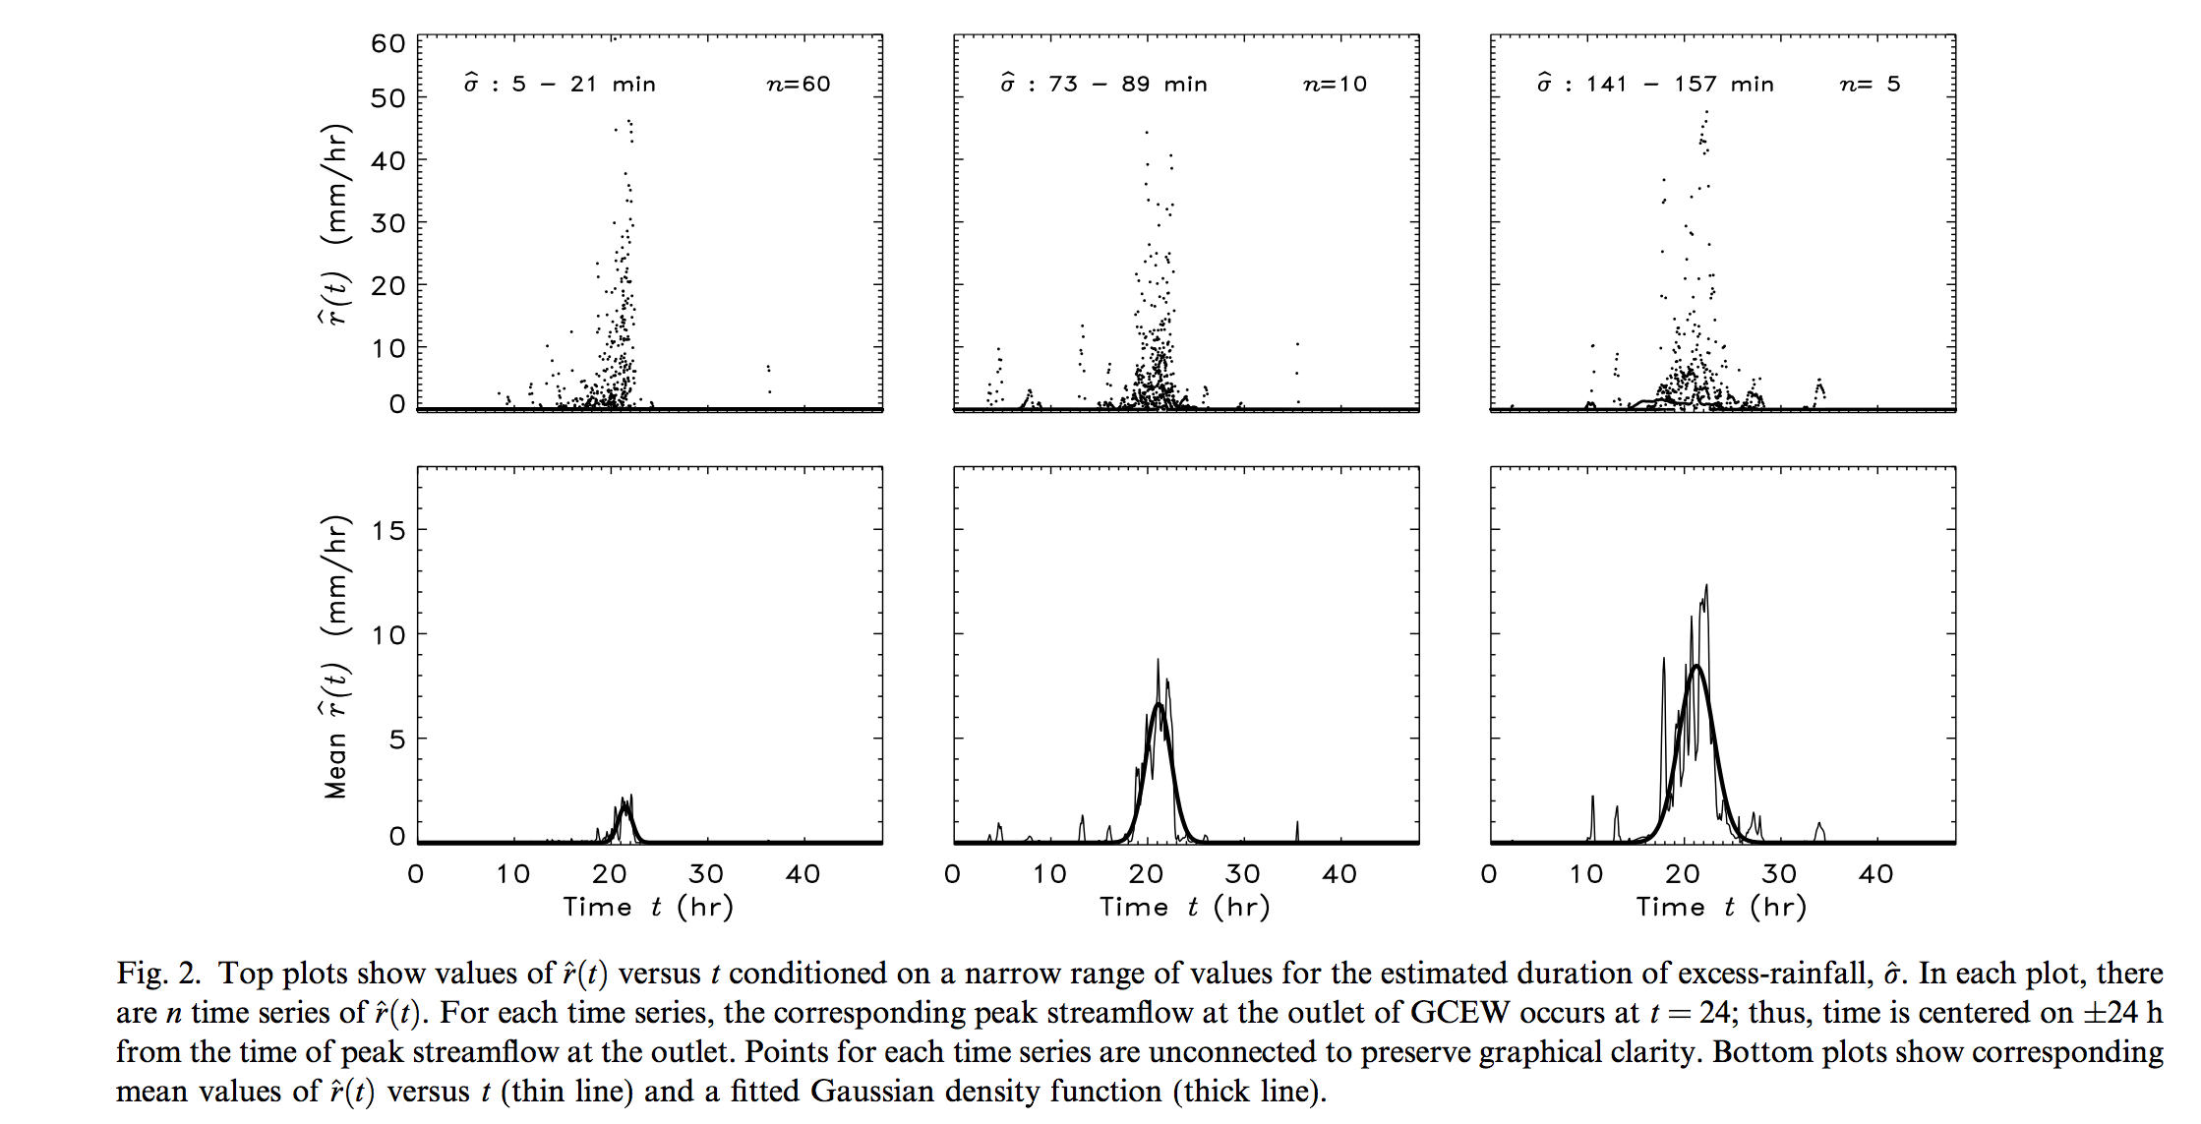
Figure 21.2 Mean excess rainfall time series given duration

Plots at the top of the figure show the estimated excess-rainfall rate versus time t conditioned on a narrow range of duration values . In each plot, there are n time series of versus time . For each time series, the corresponding peak streamflow at the outlet of GCEW occurs at t = 24; thus, time is centered on 24 hours from the time of peak stream flow at the outlet of GCEW. Plots at the bottom show the mean time series of , calculated from each plot at the top, and a corresponding fitted Gaussian density function. Qualitatively, a Gaussian density captures the overall time series pattern for each group. This result is also found for other groups of . Points for each time series are unconnected to preserve graphical clarity. Bottom plots show corresponding mean values of versus time (thin line) and a fitted Gaussian density function (thick line).

21.2 Estimating mean basin response function given duration
Streamflow hydrographs were simulated throughout GCEW by solving a coupled set of network based mass and momentum conservation equations (Eqs. (19.1) and (19.2) in Lecture 19). CUENCAS solves the coupled equations numerically and simulates hydrographs at all channel links in a network. Simulations were limited to a few basic physical processes and conditions in order to gain an understanding of their interaction and influence. The topography of GCEW was represented by a DEM of 30 m resolution, which Mantilla and Gupta [15] found to be the lowest resolution that can accurately characterize the network structure of a basin. The river network was extracted from the DEM using CUENCAS and it compared well with Blue Line maps of the basin.
An ‘instantaneous’ pulse of excess rainfall with a depth of 0.001 m (1 mm) was used to force a simulation. To represent this pulse, each hillslope in GCEW was covered uniformly with water having a depth of 0.001 m and then the basin was allowed to drain. A linear storage–discharge relationship with flow velocity was used to characterize runoff from a hillslope. Likewise, a linear storage–discharge relationship with flow velocity 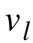 was used to characterize runoff from a link. Hillslope and link dynamics included storage attenuation, and simulated streamflow was sampled at each outlet of the 552 links that comprise the DEM-extracted river network. Under the conditions described above, a simulated hydrograph for a given subbasin in GCEW is a GIUH. Therefore, a simulation produced a family of 552 GIUH’s characterizing the sampled subbasins and outlet of GCEW. This family of GIUH’s was viewed as a family of response functions, with each response function determined by flow dynamics and network structure. Fig. 3 shows the results of our conditional analysis on simulations where 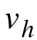 = 0.1 m/s and = 1 m/s.
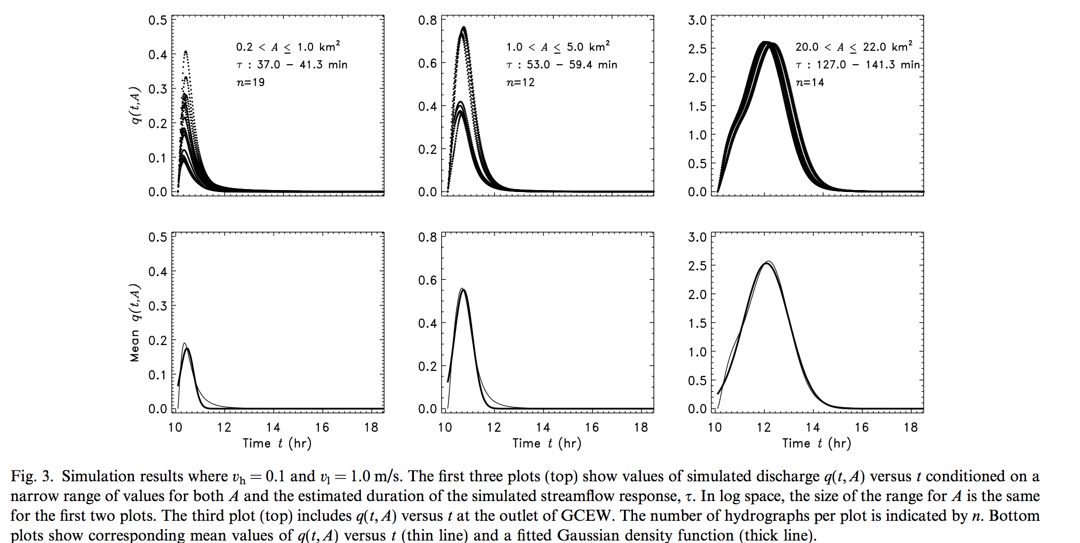
Figure 21.3 Mean basin response function time series given duration

To make Fig. 21.3, we first defined a range of areas A and then a range of basin-response durations on which to condition the analysis. We evaluated the duration for each subbasin using a surrogate measure defined as where = 0.001A is the total discharge volume (m³) and is the simulated discharge peak (m³/s). The three plots at the top of Fig. 21.3 show discharge versus time conditioned on a range of A and τ values. The third plot includes the response function for the outlet of GCEW. Plots at the bottom show the time series of mean discharge calculated from each plot at the top, and a corresponding fitted Gaussian density function. Qualitatively,
a Gaussian density captures the mean time series pattern for each group. This result is also found for other groups of A and τ. This exercise illustrates that a Gaussian density function is a reasonable first-order approximation for the shape of the conditional mean basin-response function when = 0.1 m/s and = 1 m/s. Simulations using other values for and lead to the same conclusion.

21.3 A relationship between the duration of basin-response and drainage area
To examine how the response function in GCEW changes with respect to drainage area, each value of τ obtained from a simulation was plotted against A in log–log space. Three simulations were run where = 0.1, 1.0, ∞, and = 1 m/s. The condition =∞ means that all of the water on each hillslope flows instantaneously to its adjoining link; thus, hillslopes do not affect basin response. For each simulation scenario, Fig. 21.4 shows that a curve relates τ and A and that this curve appears to become linear on a log-log plot as A increases. For basins of order , the relationship between τ and A is captured, on the average, by a power law . This relationship holds for other values of and is used to develop a generalized GIUH. It is a generalization of width-function GIUH.
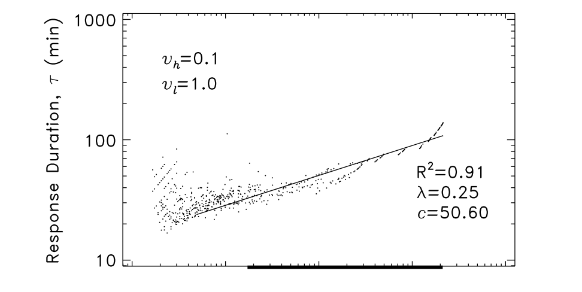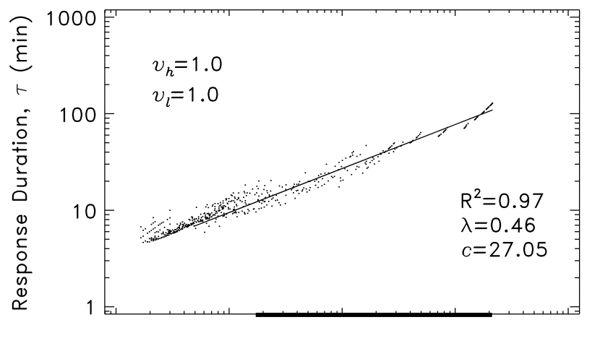
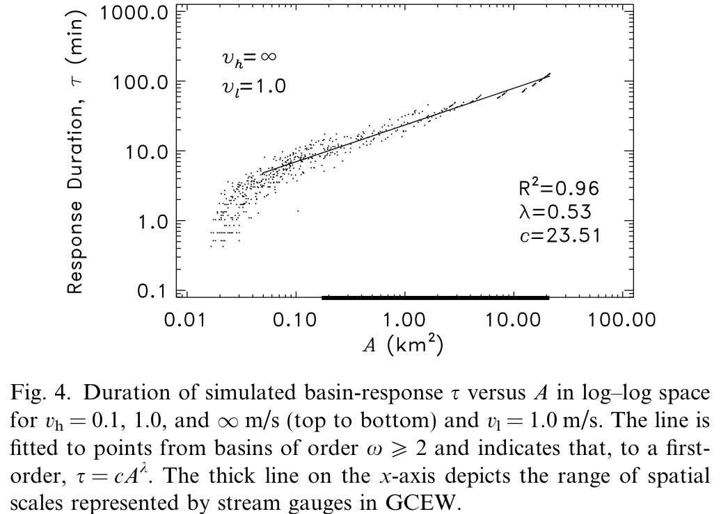
Figure 21.4 A relationship between the duration of basin-response and drainage area

Power law parameters in the relationship are sensitive to surface routing conditions. As shown in Fig. 21.4, c decreases and λ increases as hillslope velocity increases. On the other hand, c and λ remain the same if, for example, the initial excess rainfall depth is changed from 1 to 5 mm. The relationship is closely related to the shape and scale of width functions in GCEW. First, a similar relationship between τ and A for basins of order is obtained for a simulation where =∞ and channeled water in GCEW is routed translationally with constant velocity and no storage attenuation. In this situation, the hydrograph for a subbasin in GCEW is equivalent to the width function GIUH for that subbasin, and, by extension, the relationship between τ and A can be obtained directly from width functions.
Second, multiplying by a constant velocity v gives a relationship between distance and A that is comparable to Hack's Law (Lecture 13). Hack's Law for GCEW using basins of order gives , where L is defined as the longest channel length in a basin. It is equal to the base length of its width function.

21.4 Explicit Representations of Mean Excess Rain and Mean Basin Response
Following Furey and Gupta (2007), the mean excess rainfall can be expressed as,

(21.2)

where, is the expected total depth of excess rainfall given , ‘a’ is the mean area of all hillslopes that drain into the links in a basin, ‘s’ is time since the beginning of the event, and is assumed to be a normal density function with parameters and as illustrated in Section 21.1. The parameter is a measure for the duration of the expected time series of excess rainfall. If the value of is fixed, then theoretically the value of is fixed as well. The parameters and have units of time giving the unit volume per time. Integrating Eq. (21.2) over time gives the expected volume of rainfall over the mean hill area,.

Second, assume that

(21.3)

where ‘n’ is the total number of links in a basin of area A, is a normal density function with mean and standard deviation . The parameter is a measure for the duration of the expected response function. If the value of is fixed, then theoretically the value of is fixed as well. Here, is dimensionless and the second equality follows by assuming that l/a is the constant.
Simulated response functions for GCEW change in shape with an increase in spatial scale or drainage area. This change in shape is expressed, on average, by a power law as; see Section 21.3. Although Eq. (21.3) shows that the expected response function changes with A, but it does not explicitly capture this change-in-shape feature.

References

Brutsaert, W. Hydrology: An introduction, Cambridge, 2005.
Furey, P. R., and V. K. Gupta, Effects of excess rainfall on the temporal variability of observed peak discharge power laws, Advances in Water Resources 28, 1240–1253, 2005.
Furey, P. R., and V. K. Gupta, Diagnosing peak-discharge power laws observed in rainfall-runoff events in Goodwin Creek experimental watershed, Advances in Water Resources, 30, 2387-2399, 2007.

